# Team Project Assignment

# You are given a web application which is an online store, also a rough specification regarding the requirements. Your task is to find the misconceptions in the specification, the broken functionalities, user experience problems, security issues and do some automation for the repetitive work.

# Your team can pick any tools test planning, test execution and bug reporting. But it’s very important to document all your work in corresponding issues in the issue tracker you have chosen.

## Project Team Members

The Development lead is Kevin Scott​, the lead of Design and Art is Kevin Lynch​ and the Project Manager is Rob High​. Communicate well with them in the issue tracker (JIRA, Trello, GitHub) and address issues to the relevant department.

## Software Requirements

1. Introduction
   1. Purpose  
        
      The purpose of this document is to present a detailed description of Online Web Store application (hereinafter called Online Store, Store or simply Project). It will explain some of the key features at very high level.
   2. Scope  
        
      The document will cover the basic functionality on high level regarding the Online Store. The user-management system, the Orders creation and operation and its respective details. The administrative part – what the special user (Administrator) is not in the scope
2. Overall description
   1. System environment  
        
      The Store has two active actors and one cooperating system. All of them are accessing their parts from the internet. The Unregistered user can access the basic functionality of the project. One can view products, categories and pictures. The Registered user can access some of the basic CRUD operations over the orders. One can create order, edit its own orders, add and remove details from it, rate products as well.
   2. Vocabulary
      1. Product page ​– A product page is the main information block regarding a product. It consists of the Product Name in the middle. Like and Add to cart buttons. Should contain Product price in USD, also if discount is available. And a cover image/s on the very right side. Form for leaving product rating (should be available by adding/removing starts). Additional information about the product can seen below. In order to improve our sells, we should suggest what are products the rest of the users bought in a “People who bought this item also bought” section. Here user will get quick image links to other products.  
           
           
         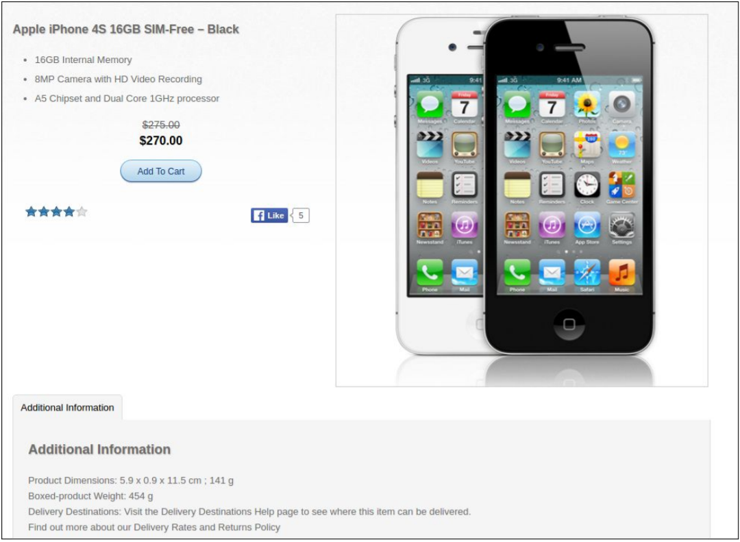
      2. Simple view​ – A simple view is the main short information block regarding a product. It consists of the Product name in the left side. The picture itself at the right. On mouseover should allow zoom and a slider with all available images. A short description under it, no more than 500 characters. Should contain Product price in USD, also if discount is available. Form for leaving product rating (should be available by adding/removing starts). Like and “Add To Cart” buttons.  
           
         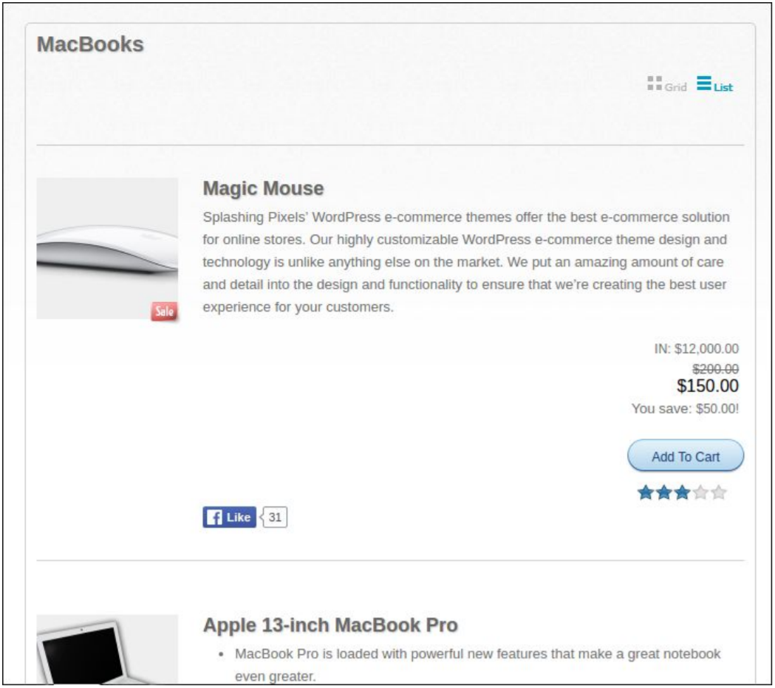
      3. Latest products view​ – This is a quick view regarding latest added products. Users should see 4 items in random order. In every product’s view is placed Product name, image and a link to the relevant Product page.  
           
         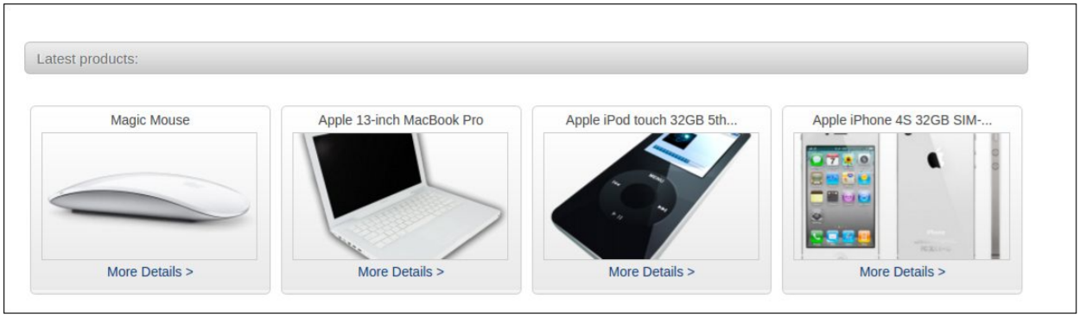
   3. Functional requirement specification  
      1. Use Case 1 (Accessing the system) The system is accessed through the internet from its initial URL. It loads header, navigation bar and a home page
      2. Use Case 2 (Navigation bar) The navigation bar has navigational hyperlinks to the Home, Product category, Services & Support, All Products. As well as it should have navigation to the Checkout and My Account pages.  
         1. Navigation bar – Checkout  
            When the visitor is unregistered, My account hyperlink navigates to the Log in and Register page should be present. When the visitor is registered hyperlink to the Logout page should be present as well. When user is successfully logged out, there should be a redirect to the Checkout page.
         2. Navigation bar – user management  
            When the visitor is unregistered, My account hyperlink navigating to the Log in and Register page should be present. When the visitor is registered hyperlinks to the My account page and to Logout page should be present instead. When user is successfully logged out, there should be a redirect to the Log in and Register page.
      3. Use Case 3 (Home page)  
         The home page shows the Product blocks in random order in a slider section. Clicking on the Slider’s buttons on an album leads to the Next/Previous slide. Latest products section should be available at the bottom.
      4. Use Case 4 (Products Category Page)  
         Information regarding the sub-categories is shown as links (e.g. iMacs, iPods) in the navigation pane, where user can choose where to go next. Display functionality offers the possibility to show how products are shown, based on the following views:  
         -Grid  
         -List  
         The respective information regarding the products is shown on the page in a form of random results. Simple view should display the products. When the filter is applied (sub-category) the page should display the respective products found. If the input data is invalid, a respective error box is shown, indicating that products are “Not Found” and “Apologies, but the page you requested could not be found. Perhaps searching will help.” tip.
      5. Use Case 5 (Services & Support)  
         Information regarding what the company can offer as extra customer case. User should be able to navigate to Service and Support pages, where we provide additional details how we can help.
      6. Use Case 6 (Add product to cart)  
         In order to add product to cart, one needs to login to the site. By clicking “Add to cart”/”Buy Now” from any product view, the user is informed that the item is added to its cart. Two options are given: either “Go to Checkout” or go back to “Continue Shopping”. Last one redirects to Home page. If the first option is selected, user should gets to the Checkout page and prompted to follow 3 steps process in order to finish the order. First stage of the flow is “Your cart” section, where user can check the Product information (by clicking on each product name) again and select Quantity. Total price (product, shipping, tax) is shown here. We allow removal of products here. Clicking on “Continue” button leads to “Info” section, where we request all details needed to process the order. We provide the option to calculate the Shipping price based on county and state. Billing and Shipping addresses may differ. The mandatory fields are:  
           
         - Email address  
         - First Name  
         - Last Name  
         - Address  
         - Country  
         - State  
         - City  
         - Postal Code  
         - Phone  
           
         Review and purchase section displays information about the costs of Total Shipping, Item Cost, Item Cost and Total Price. If everything is validated, the user is taken to the next “Final” section. Here user can finally review and approve the product order
      7. Use Case 7 (All products)  
         Clicking on the “All products” hyperlink from the header navigates to the All products page. For any user, we show Simple views of random products. Each Product name is hyperlink, leading to product page.
      8. Use Case 8 (My account)  
         Clicking on the My Account hyperlink from the header navigates to the My account page. Page lists the available sections:  
           
         - Purchase History  
         - Your Details  
         - Your Downloads  
         1. My account – Purchase History  
            This My account hyperlink navigates to the Purchase History page. Here we show all transactions for the current month. If there are no such transactions - just inform the user with a friendly message.
         2. My account – Your Details  
            This My account hyperlink navigates to the User details page. Here we allow edition and update of the Billing/contact details and Shipping Address.
         3. My account – Your Downloads  
            This My account hyperlink navigates to the Downloads page. Here we show all purchased downloadable products for th1e current month. If there are no such transactions - just inform the user with a friendly message.
      9. Use Case 9 (Search)  
         Clicking on Search from in the header allows for product finds by given keywords. If we have such products, we should show a list with the results. If no product is found, we should display error message stating that “Sorry, but nothing matched your search criteria. Please try again with some different keywords.”

## Tasks

1. Create enough test cases to test the functionalities described in the SRS.
2. Save those test cases in simple files (TXT or XLS/X) or a test management system of your choice. Add screen shots to your test cases if necessary. Upload all the files as a single zip file in SoftUni system, in the case a test management system is used, please provide access and some screenshots of the test cases.
3. Set correct priority to your test cases depending on the functionality importance. Most important test cases that has to be run are the highest priority, the least important test cases are the lowest priority.

## Resources

The project is located at: http://store.demoqa.com/